1. Project Specification

This project aims to make a Python based program to store and manipulate (Create, Read, Update) the academic scores data of students.

1. Solution Design

This program allows user to access some features to manage academic scores data for students in one class. Functional features that should exist in this program can be seen in the Usecase Diagram below.

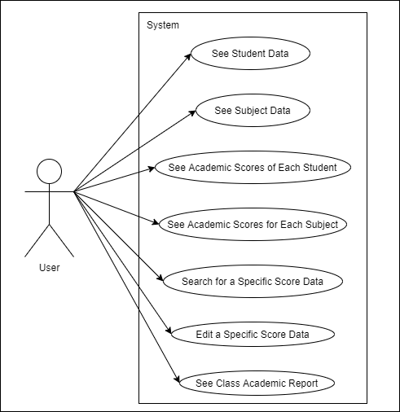

1. Implementation
2. Program Scheme
3. Load data of all students name
4. Load data of all subjects name
5. For each subject, load all academic score data including student name, individual daily task score, individual quiz score, individual middle exam data, and individual final exam data.
6. Print menu options
7. Get menu pick from user
8. If user pick menu 1, run point g-o
9. Print subjects list
10. Get subject pick from user
11. If user pick 0, then go back to point d
12. Else, print academic data for the picked subject; including subject name, highest score for that subject, lowest score for that subject, average score for that subject, and detailed score data for each student in that subject, shown in a table form.
13. Ask user if they want to edit a data for that subject (y/n)
14. If user pick n, then go back to point d
15. Else, get user input for subject name and student name
16. Get user to input new daily task score, quiz score, middle exam score, and final exam score for that specified subject and student
17. Save new scores data
18. If user picks menu 2, run point q-v
19. Print students list
20. Get student pick from user
21. If user picks 0, then go back to point d
22. Else, print academic data for the picked student; including student name, total score accomplished by that subject, mean value of all scores achieved by that subject, and detailed score data for each subject owned by that student, shown in a table form.
23. Ask user if they want to edit a data for that student (y/n)
24. Run point l-o
25. If user picks menu 3, run point x-y
26. Get user input for subject name and student name
27. Print detailed scores data for that specified subject and student in the form of table
28. If user picks menu 4, run point aa
29. Print class report; including first rank in that class, last rank in that class, and summary of the students’ score in that class (name, total score, mean score) in a table form.
30. If the user picks menu 5, then the program ends.
31. Data Structure
32. Library

This program uses one library from Python, and it is PrettyTable. PrettyTable library is used to print data in a neat table format.

1. Package

This program has one package named ‘package’. In that package there’s a Python module file named ‘calculator.py’. The ‘calculator.py’ module contains four custom built functions for statistics functions. 1) getMean() to get mean value of a collection of data stored in Python list, 2) getTotal() to get total value of a collection of data stored in Python list, 3) getMax() that returns maximum value in a collection of data and the index of that value, and 4) getMin() that returns minimum value in a collection of data and the index of that value.

1. Classes

To store data, this program contains five (5) custom built classes.

1. class SubjectList()

This class contains some functions: its constructor, function addSubject(), getSubjectIndex(), getScoreData(), and editScoreData().

There are two instance variables in this class: numberOfSubject and subjects. numberofSubject is integer, and subjects is a list of objects of the class Subject().

1. class Class()

This class contains some functions: its constructor, function addStudent(), getFirstRank(), getLastRank(), and printClassData().

There are five instance variables in this class: number, className, numberOfStudent, students, and subjectList. number is integer, className is String, numberOfStudent is integer, students is a list of objects of the class Student(), and subjectList is an object of the class SubjectList().

1. class Student()

This class contains some functions: its constructor, function addStudentScore(), function setMeanTotal(), and function printStudentScores().

There are five instance variables in this class: name, studentNumber, totalScore, mean, and studentScores. name is String, studentNumber is integer, totalScore is float, mean is float, and studentScores is a list of objects of the class ScoreDetail().

1. class ScoreDetail()

This class contains two functions: its constructor, and function setScore().

There are seven instance variables in this class: studentName, subjectName, dailyTaskScore, quizScore, midExamScore, finalExamScore, and totalScore. studentName is String, subjectName is String, dailyTaskScore is integer, quizScore is integer, midExamScore is integer, finalExamScore is integer, and totalScore is float.

1. class Subject()

This class contains two functions: its constructor, function addSubjectScore(), setMaxMinMean(), getStudentIndex(), printSubjectScores(), and rewriteFile().

There are seven instance variables in this class: name, subjectScores, mean, maxScore, minScore, maxName, and minName. name is String, subjectScores is a list of objects of the class ScoreDetail(), mean is float, maxScore is float, minScore is float, maxName is String, and minName is String.

1. Functions

There are some functions in the program’s main Python file outside of classes.

1. getAllScore(), this function reads all scores data from a txt file and saves it.
2. printMenu(), this function prints menu options to the screen.
3. Other variables exist in the program’s main Python file. Some of them are integer like ‘menu’ and ‘pick’, some of them are String like ‘edit’, and ‘subjectName’, and some of them are objects like ‘class10A’.
4. Evidence of Working Program
5. Menu 1

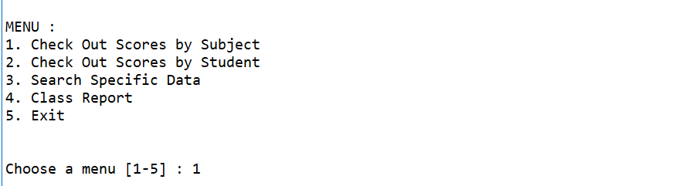

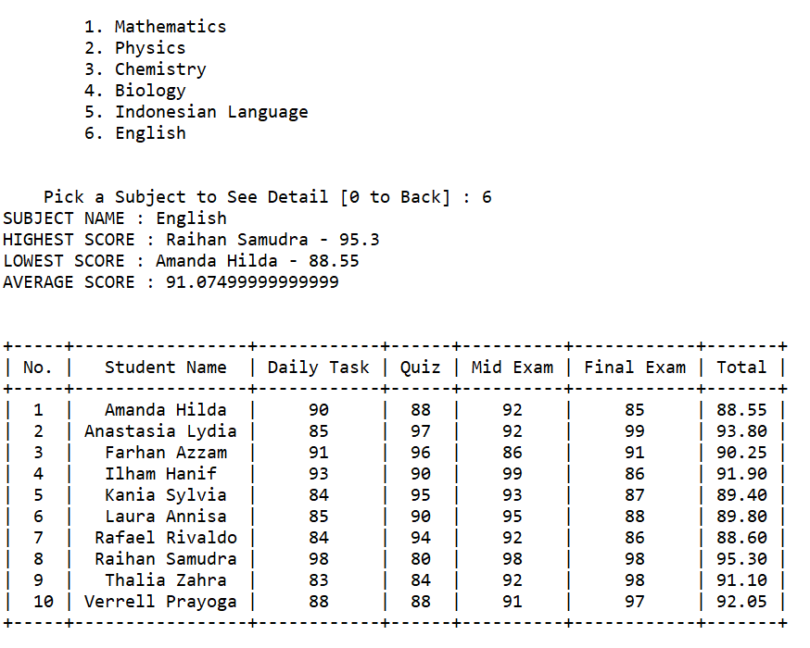

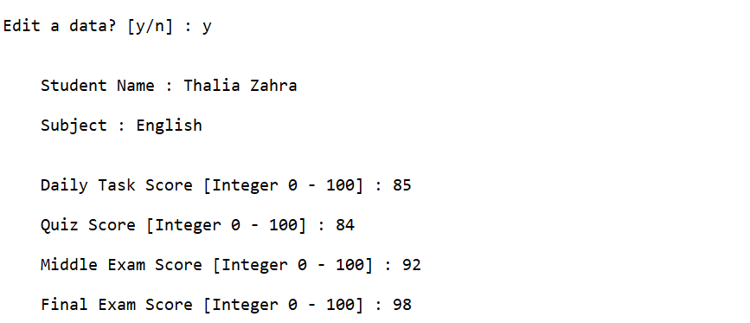

1. Menu 2

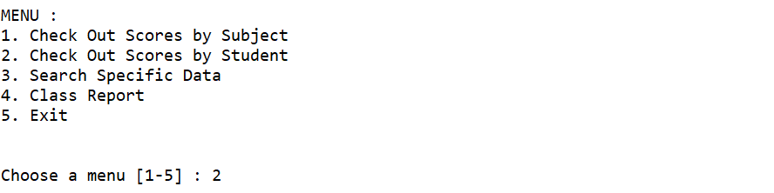

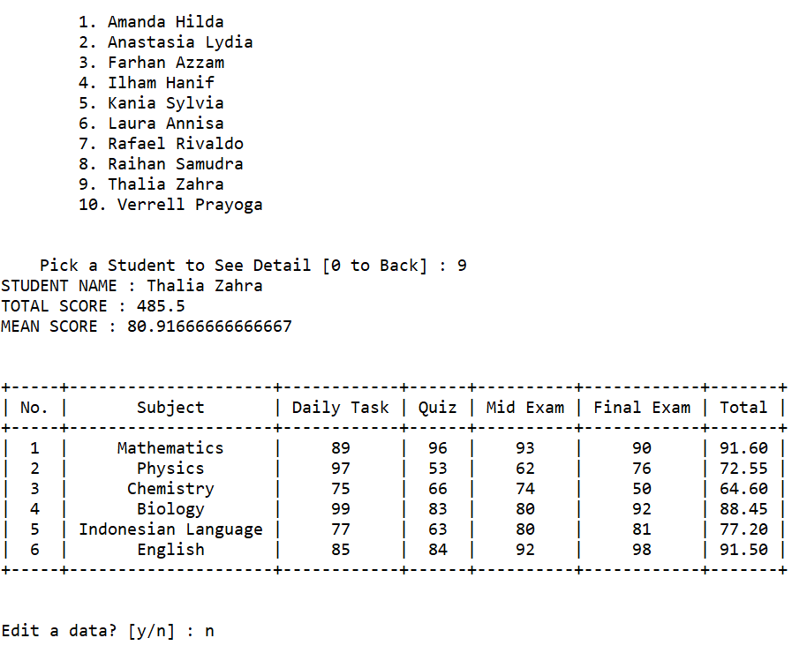

1. Menu 3

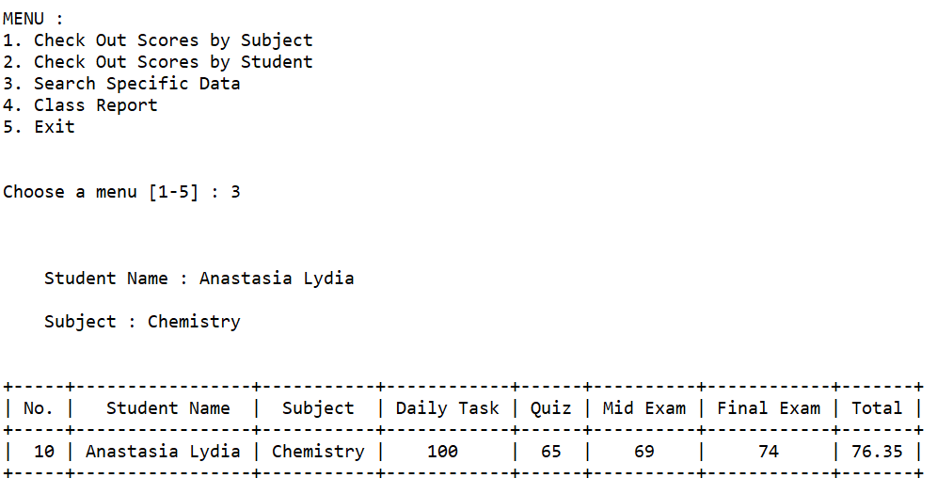

1. Menu 4

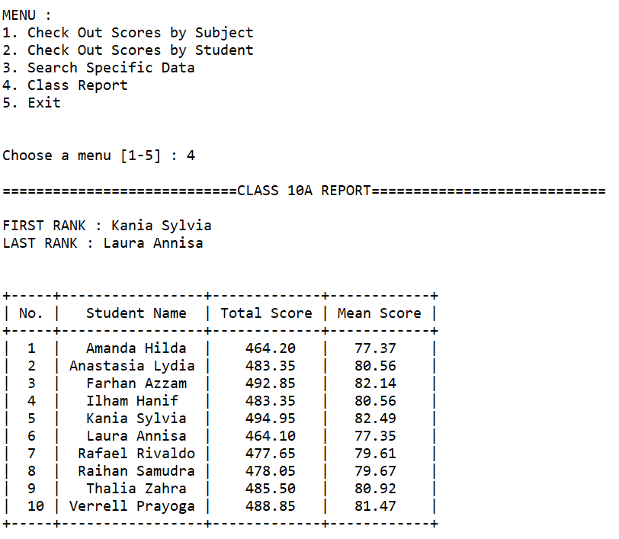

1. Menu 5

